**Create Eureka Discovery Server And Register Microservices**

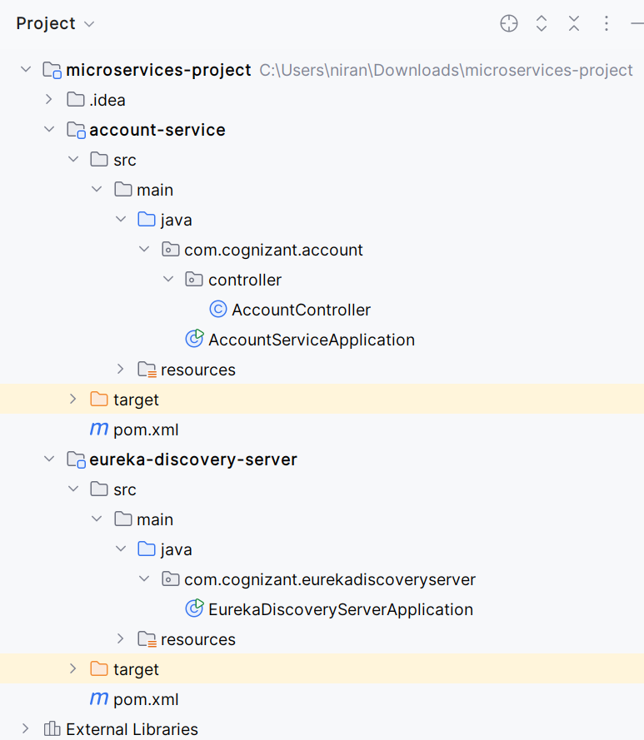

**AccountServiceApplication.java**

package com.cognizant.account;  
import org.springframework.boot.SpringApplication;  
import org.springframework.boot.autoconfigure.SpringBootApplication;  
import org.springframework.cloud.client.discovery.EnableDiscoveryClient;  
  
@SpringBootApplication  
@EnableDiscoveryClient  
public class AccountServiceApplication {  
 public static void main(String[] args) {  
 SpringApplication.*run*(AccountServiceApplication.class, args);  
 }  
}

**AccountController.java**

package com.cognizant.account.controller;  
import org.springframework.web.bind.annotation.GetMapping;  
import org.springframework.web.bind.annotation.RestController;  
  
@RestController  
public class AccountController {  
 @GetMapping("/account")  
 public String getAccountDetails() {  
 return "Account details from Account Service";  
 }  
}

**application.properties**  
spring.application.name=account-service  
server.port=8081  
eureka.client.service-url.defaultZone=http://localhost:8761/eureka

**EurekaDiscoveryServerApplication.java**

package com.cognizant.eurekadiscoveryserver;  
import org.springframework.boot.SpringApplication;  
import org.springframework.boot.autoconfigure.SpringBootApplication;  
import org.springframework.cloud.netflix.eureka.server.EnableEurekaServer;  
  
@SpringBootApplication  
@EnableEurekaServer  
public class EurekaDiscoveryServerApplication {  
 public static void main(String[] args) {  
 SpringApplication.*run*(EurekaDiscoveryServerApplication.class, args);  
 }  
}

**application.properties**

server.port=8761  
eureka.client.register-with-eureka=false  
eureka.client.fetch-registry=false  
logging.level.com.netflix.eureka=OFF  
logging.level.com.netflix.discovery=OFF

